VySkan
Product Name | 4G LTE Intelligent Livestock & Large Pet Tracker
Product Model | VP-Herd
Smart. Rugged. Reliable.
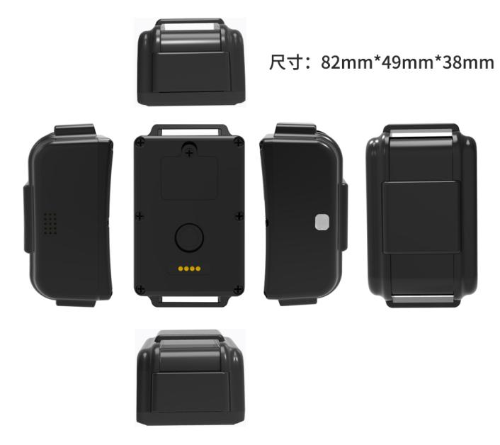
Specifically engineered for the livestock industry and large pet management, the Vyskan VP-Herd is a professional-grade 4G LTE tracker that merges high-speed wireless communication with dual-constellation GPS/BDS positioning. Encased in a reinforced IP67 waterproof housing, it features a built-in 3-axis accelerometer for intelligent power management and proactive health monitoring. Whether managing cattle in remote pastures or tracking large assets, the VA07-Pet provides real-time visibility through a global positioning service platform.

- Core Value
- Dynamic Multi-Mode Tracking
Offers five distinct operating modes—from high-frequency 10-second updates for active recovery to ultra-efficient 24-hour check-ins—allowing users to balance monitoring intensity with battery longevity via remote commands.
- Industrial-Grade Durability
Built with heavy-duty nylon plastic and rated at IP67, this device is dustproof and highly water-resistant, ensuring stable operation in extreme outdoor environments from -20℃ to 75℃.
- Intelligent Loss Prevention
Features advanced "Sound & Light Pet Seeking" and virtual geofencing. In areas with weak cellular coverage, the built-in memory caches trajectory data to ensure no movement is lost, uploading it automatically once connection is restored.

- Target Applications
- Livestock Management
High-capacity 4000mAh battery and multi-mode tracking provide months of monitoring for cattle and sheep in open pastures.
- Large Pet Security
Sound and light seeking functions allow owners to locate pets quickly in low-visibility or dense environments.
- Asset & Vehicle Tracking
Built-in industrial-grade FPC antennas and magnetic charging port make it a versatile tool for asset protection.
- Technical Specifications
  - Cellular & GNSS
Category | Specification | Description
Network Bands | 4G LTE (FDD/TDD) & 2G GSM | Comprehensive network coverage optimized for regional requirements.
Positioning Mode | GPS + BDS + AGPS + LBS | Multi-constellation tracking for accurate visibility even in challenging environments.
Startup Time | Cold: 32s |  Hot: 1s | Rapid Time-To-First-Fix (TTFF) for instant location acquisition.
Tracking Sensitivity | -162 dBm | Maintains strong signal lock under heavy foliage or rural conditions.
  - Power & Electrical
Category | Specification | Description
Battery Capacity | 4000 mAh (3.7V Polymer) | High-density battery for long-term standalone operation.
Operating Voltage | DC 3.4V - 4.5V | Internal power system designed for stability.
Working Current | Avg. 59.8mA @ 4V | Efficient power consumption during active tracking.
Charging Interface | Magnetic Port + Serial | Convenient, waterproof magnetic charging with data expansion support.

  - Interfaces & Expandability
Category | Specification | Description
Audio/Visual | Speaker + Multi-Color LEDs | Supports "Sound & Light" seeking for rapid localized retrieval.
Sensor | 3-Axis Accelerometer | Enables intelligent wake-up and real-time posture/activity monitoring.
Remote Upgrade | OTA Support | Supports online remote configuration and firmware upgrades.
  - Physical & Environmental
Category | Specification | Description
Dimensions | 82mm * 49mm * 38mm | Compact industrial design optimized for animal collars.
Material | Reinforced Nylon Plastic | Built for high impact resistance and outdoor durability.
IP Rating | IP67 | Fully dustproof and waterproof against heavy rain or immersion.
Operating Temp. | -20℃ to 75℃ | Resilient performance in diverse climates.
- Deployment & Integration
Rapid Deployment & Smart Logic: The VP-Herd is designed for immediate field rollout with an intuitive "one-click" power system and magnetic charging. It features a built-in low-power mode that automatically adjusts reporting intervals when battery drops below 20%, ensuring critical visibility when it's needed most. The device effortlessly integrates with global service platforms, offering 180 days of historical trajectory storage and blind-zone data compensation.
- A personalized service prepared for you
- 1× VP-Herd Sample Device (Pre-configured)
- Full API & Protocol Documentation
- 1-on-1 Technical Support from our Field Engineers
- Contact us
Website: https://vyskan.com/
Email: marketing@vyskan.com

